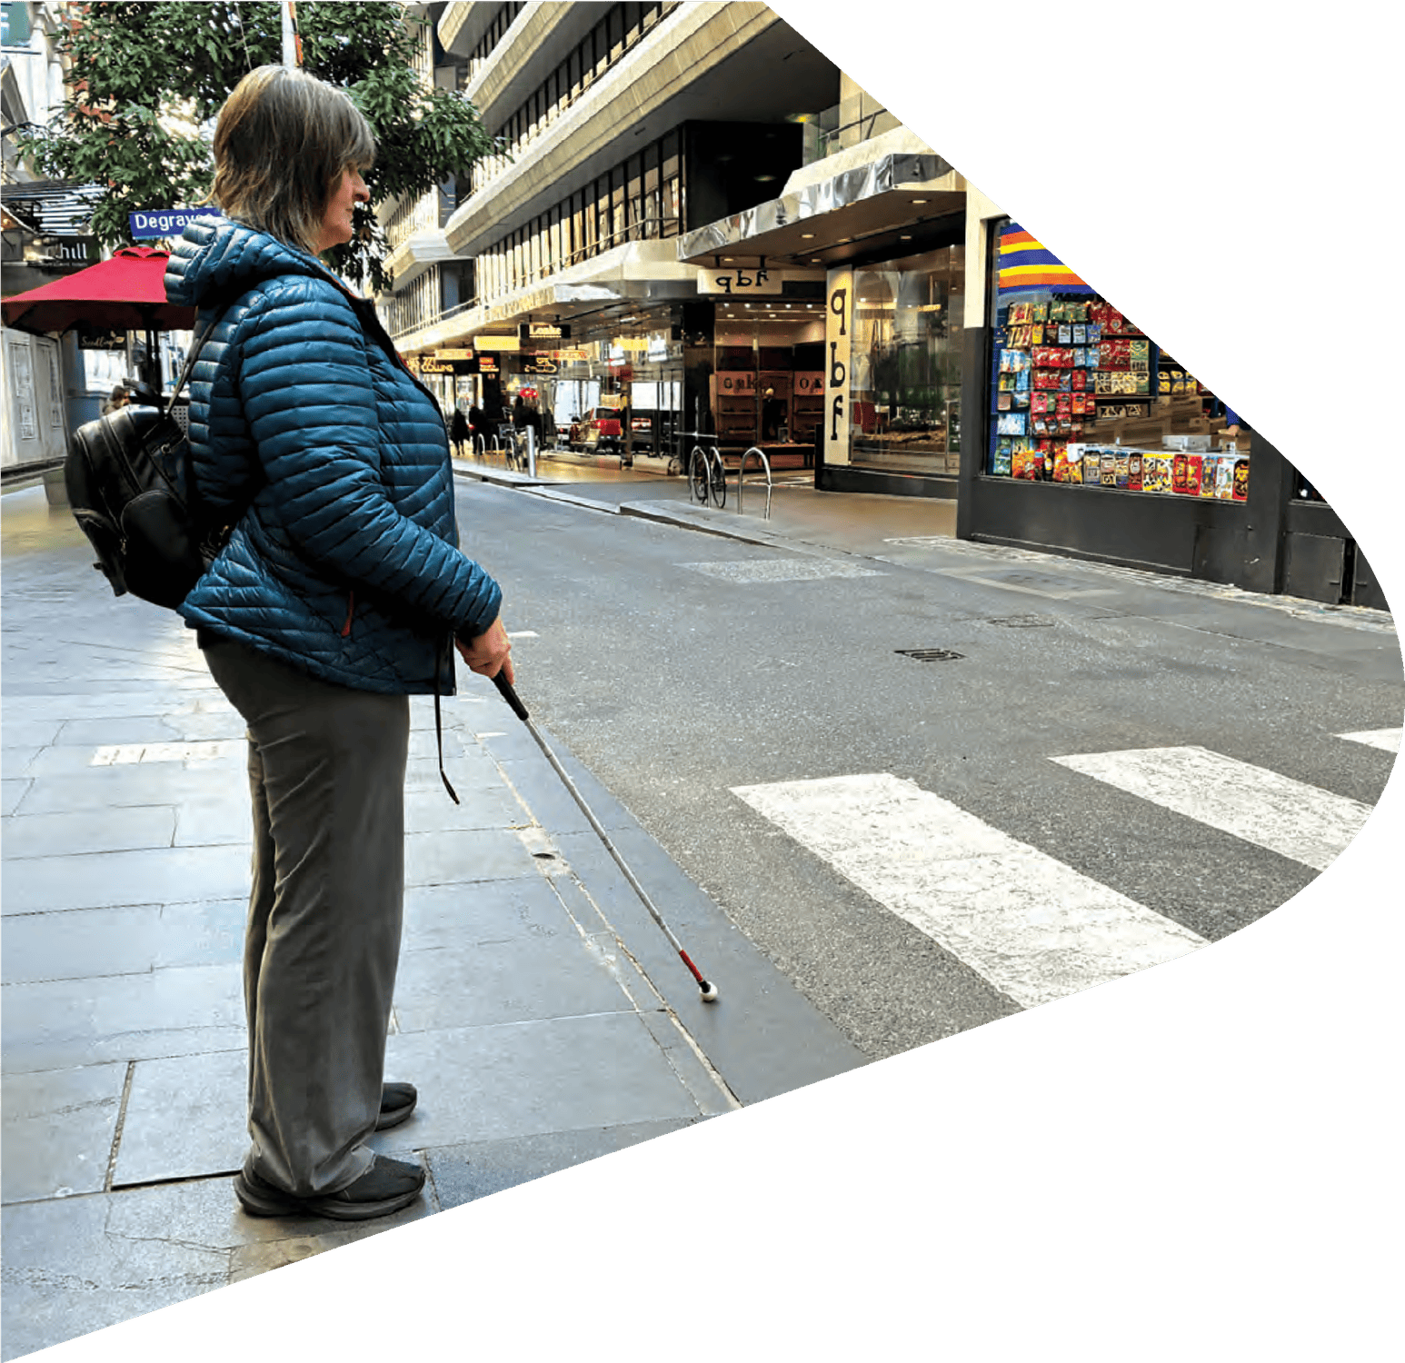

DB-SAFE

Deafblind – Safer Access For Everyone


This guide is about staying safe on the road. It is for deafblind people and the people who support them.

Why moving safely matters
Active mobility means you choose how you move, using your senses, your mobility aids, and your skills. This builds confidence and helps you stay safe when crossing roads.

The issues
Deafblind people report the same problems, whether they travel with a guide or on their own:
- Judging the speed, distance and direction of traffic.
- Moving safely from the kerb onto the road.
- Feeling steps, edges and changes in the ground.
- Uneven footpaths, which can cause falls.
- Low contrast between the road and the footpath.
- Obstacles or hazards in the way.
- People not knowing how to help.
The biggest worries are: falls, feeling less confident, and near misses with cars.
Crossing without a guide is not always the right choice. But there are still ways to move and cross more safely — mainly by getting as much information as possible about what is ahead, so the body has time to prepare, respond, and move safely.

Active mobility and passive mobility
Passive mobility is when someone else makes the decisions for you. You might prefer to be guided by someone all the time. This can help when you are tired or somewhere new, but it can also mean you use your own skills less.
Active mobility is when you make the decisions. It looks different for everyone — it might mean travelling with a guide, or walking to the letterbox alone.

Tools that can help
A long cane helps you feel changes in surface, kerbs, edges, and obstacles ahead. It also helps drivers see you, so they can slow down or wait.
Some mobility aids vibrate to tell you about doorways, obstacles, or trains.

Safe road crossings
The safest crossings have traffic lights. Next best are wombat crossings (raised, so cars slow down) and pedestrian crossings at single-lane roundabouts (cars slow down and come from one direction). Take extra care at multi-lane roundabouts.

Tips for crossing safely
- Plan your trip.
- Use your body and cane to show drivers you want to cross.
- Once on the road, keep walking — don’t stop or rush.
- Wear bright colours.
- Avoid standing near parked cars or trees, where drivers can’t
see you.
- Use traffic islands to cross in two smaller steps.
- Ask a nearby person for help if you need it.
Safer to cross: traffic lights, zebra crossings, familiar routes, roads where you only check one direction, and away from turning traffic.
Try to avoid: busy multi-lane roads, bends, hilltops, and unfamiliar places.

People who can help

Orientation and Mobility Specialist
Teaches you to move safely, confidently and independently, and supports your judgement about when to cross.

Physiotherapist
Helps your balance, strength and walking.

Exercise Physiologist
Builds strength and stamina for uneven ground.

Communication Guide or Support Worker
Trained in guiding. Supports you the way you want, and helps you build your own skills.

Reporting hazards
Snap Send Solve is a free app for reporting broken footpaths, unsafe kerbs, potholes, and other hazards. Take a photo, confirm the location, describe the issue, and send it to the council.

Understanding your body in space
Proprioception means knowing where your body is and how it is moving, without needing to see it. It helps with balance, avoiding falls, and knowing how big a step to take.

The environment and support
Good support is thinking about the person, the environment, and the type of help needed. Sometimes the best support is to step back and let the person explore safely.
Relying only on someone else for all information can be risky if that information is late or missing.

For people supporting deafblind clients
- Ask before helping — don’t assume.
- Talk about what helps the person feel safe.
- Learn the roles of O&M Specialists, Physiotherapists, and Exercise Physiologists.
- Choose words carefully — and “dangerous” or “tricky” can cause fear.
- Notice hazards and speak up for safer spaces.
- Step in if someone is unsafe.

For deafblind people and families
- Learn the road safety risks that matter most to you.
- Consider a long cane to help preview your surroundings.
- Refresh O&M skills if health, vision, or circumstances change.
- Use your senses actively to support safer movement.
- Plan safe routes and practise with an O&M Specialist.
- Think about time of day – busier times may be less safe.
- Think about time of day — busier times may be less safe.

Training reflections for staff
For support workers and communication guides to think about:
- What do you know about your clients’ experience with Orientation and Mobility training?
- How does each of these help with mobility and road safety: O&M Specialist, Physiotherapist, Exercise Physiologist, Communication Guide or Support Worker?
- Where can your clients walk independently, without guiding?
- How can road safety hazards be reported?
- What are three safer places to cross, and why?
- List three tips for safe road crossings.
- List three things to avoid when crossing roads.
- What senses do your clients use to move safely?

More help
Watch the DB-SAFE video and the DB-SAFE Road Crossing and Deafblind People video. Ask your support worker or Able Australia for the links.
Scan for
DB-SAFE

Videos

More information:
Transport Victoria — crossing the road safely: https://www.transport.vic.gov.au/road-and-active-transport/activetransport/pedestrians-and-walking/crossing-the-road-safely
Video — crossing the road when you are blind or have low vision: https://www.youtube.com/watch?v=gujjA-6Y3F8
Please read this guide together with watching both the DB-SAFE video and the DB-SAFE Road Crossing and Deafblind People video, which can be found via the QR code below.

Able Australia acknowledges the Traditional Owners and custodians of the land, sea and sky on which we live, work and provide our services. We pay our respects to the Elders past and present. They hold the connection to this country through their people, culture, traditions and their dreamtime. We will continue our learning and support of the oldest continuous culture on earth and stand united in their voice that this land is and always will be Aboriginal land.
Able supports and celebrates all human diversity.
NATIONAL OFFICE
413 Canterbury Road,
Surrey Hills VIC 3127.

WEBSITE
ableaustralia.org.au

MAILING ADDRESS
Locked Bag 4000,
Surrey Hills VIC 3127.

GENERAL ENQUIRIES
1300 225 369

